Read me
Mathematical Model of Torso (MMT)

MMT is used for computer simulations of SPECT/CT in nuclear cardiology (virtual patient)
MMT includes 3 files scaled on 128x128x128:

efg.dat – this file generates the general 3D anthropomorphic mathematical phantom, which includes main torso organs. Fig.1.

ae3.dat – the attenuation map for the MMT for gamma quanta of 140.5keV (Tc-99m) Fig.2.

efg31.dat – this file generates 3D Tc-MIBI distribution in the virtual patient MMT. Fig.3.

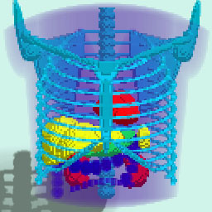
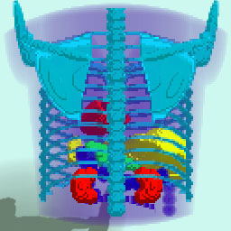

Fig.1. 3D MMT phantom (anterior and posterior)

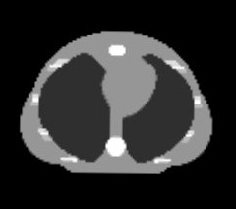


Fig.2. Attenuation map for the MMT for gamma-quanta of 140.5keV (Tc-99m).
Cross and longitudinal slices of the 3D attenuation map are shown.

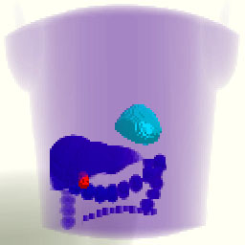

Fig.3. 3D Tc-MIBI distribution in the virtual patient MMT.

